Spring Cleaning? Do you have unwanted Spectacles cluttering up your draws?
The Lions Club of Farnham will make great use of any that you don’t want.
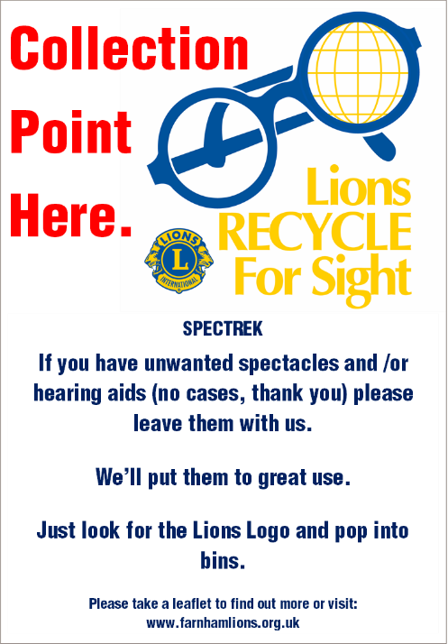
For 100 years Lions clubs all over the world have been working on projects designed to prevent blindness, restore eyesight and improve eye health and eye care for hundreds of millions of people worldwide.

One way of doing that has long been the collecting and recycling of unwanted ‘specs’.

In 2016 Lions clubs in the south of England collected over 140,000 pairs of spectacles and were part of the 300,000 that were sorted and processed by Chichester Lions and then shipped to Medico France to be recycled or sent directly to eye clinics in countries such as Papua New Guinea, Ghana, Nigeria and Nepal. Almost 3 million pairs have been collected in total by Lions Clubs in the south of England. Of those Farnham Lions has contributed over a quarter of a million.

And nothing is wasted. The Recycling of scrap material from broken and unsuitable spectacles yields funds which support the sorting operation and provide the financial support to eye related projects in the UK and overseas. Over £200,000 has been raised from scrappage in the last five years in the UK.

So, please look out for Lions labelled collection boxes which can be found at Farnham Hospital, at Farnham Opticians: Vision Express, Leightons, C E Hall, The Optical Studio and at the following Farnham branches of charity shops. Age UK, Downing St Charity Shop, Phyllis Tuckwell, RSPCA, Oxfam, British Heart Foundation, Cancer Research; Sue Ryder and Blue Cross.

Other Opticians and Charity shops may have similar collection schemes and would welcome your unwanted specs.

